Pre Requisites
Windows + R keys together
Type Gpedit.msc
Press enter
Administrative templates

Page 241 – current progress

Changes
Name | Path location | Change too
Interaction prevention of anti virus for no admin users | Administrative templates\ Windows components \ Microsoft Defender Antivirus \ Client interface | Enable headless UI mode setting and set the option to Enabled. Select OK.
block at first sight | Computer configuration\Administrative templates\Windows Components\Microsoft Defender Antivirus\MAPS | MAPS section, double-click Configure the 'Block at First Sight' feature, and set it to Enabled, and then select OK.
Turn on cloud protection | Administrative templates \Microsoft Defender Antivirus \ MAPS | Double-click Join Microsoft MAPS. Ensure the option is turned on and set to Advanced MAPS. Select OK.
Configure remediation options | Windows components\Microsoft Defender Antivirus\Scan\  Create a system restore point. | Enabled
Turn on catch-up quick scan | Policies then Administrative templates \Windows components\Microsoft Defender Antivirus\Scan\Turn on heuristics | Set the option to Enabled.  Select OK.
Turn on heuristics | Policies then Administrative templates \Windows components\Microsoft Defender Antivirus\Scan\Turn on catch-up quick scan | Set the option to Enabled.  Select OK.
Manage event-based forced updates | Policies then Administrative templates \Windows components\Microsoft Defender Antivirus\Scan\Check for the latest virus and spyware definitions before running a scheduled scan | Set the option to Enabled.  Select OK.
Monitor file and program activity on your computer | Policies then Administrative templates \Windows components\Microsoft Defender Antivirus\Scan\Scan removable drives | Set it to Enabled.  Select OK.
Activate defender | Computer Configuration\Administrative Templates\Windows Components\Microsoft Defender Antivirus\Turn off Microsoft Defender Antivirus | Set it to Disable.  Select OK.
Unwanted app protection | Computer Configuration\Administrative Templates\Windows Components\Microsoft Defender Antivirus\Configure detection for potentially unwanted applications | Set it to Enabled and block.  Select OK.
Active protection | Computer Configuration\Administrative Templates\Windows Components\Microsoft Defender Antivirus\Real-time protection \Turn off real-time protection | Set it to Disable.  Select OK.
File monitoring | Computer Configuration\Administrative Templates\Windows Components\Microsoft Defender Antivirus\Real-time protection \ Configure monitoring for incoming and outgoing file and program activity | Set it to Enabled and bi-directional (full on-access) .  Select OK.
Behaviour monitoring | Computer Configuration\Administrative Templates\Windows Components\Microsoft Defender Antivirus\Real-time protection \ Turn on Behaviour Monitoring | Set it to Enabled.  Select OK.
Turn on monitoring | Computer Configuration\Administrative Templates\Windows Components\Microsoft Defender Antivirus\Real-time protection \ Monitor file and program activity on your computer | Set it to Enabled.  Select OK.
Further analysis enabled | Computer Configuration\Administrative Templates\Windows Components\Microsoft Defender Antivirus\ Real-time protection \ MAPS \ Send file samples when further analysis is required | Set the option to Enabled and Send all samples .  Select OK.
Set cloud protection level | Computer Configuration\Administrative Templates\Windows Components\Microsoft Defender Antivirus\MpEngine\Select cloud protection level | Set it to Enabled and High blocking level .  Select OK.
Security Intelligence updates - check for security intelligence updates | Policies then Administrative templates \Windows components\Microsoft Defender Antivirus\ security intelligence updates \Specify the interval to check for security intelligence updates | Set it to Enabled and 4 .  Select OK.
security intelligence updates sources | Policies then Administrative templates \Windows components\Microsoft Defender Antivirus\ security intelligence updates \ Define the order of sources for downloading security intelligence updates | Set it to Enabled and InternalDefinitionUpdateServer | MicrosoftUpdateServer | MMPC .  Select OK.
Stop access to inclusion list | Policies then Administrative templates \Windows components\Microsoft Defender Antivirus\ Control whether or not exclusions are visible to local admins | Set it to Enabled.  Select OK.
Quarantine folder configuration | Policies then Administrative templates \Windows components\Microsoft Defender Antivirus\Quarantine | Set it to Enabled and 60.  Select OK.
Network protection | Policies then Administrative templates \Windows components\Microsoft Defender Antivirus\Microsoft Defender Exploit Guard \ Network Protection \ This settings controls whether Network Protection is allowed to be configured into block or audit mode on Windows Server | Set it to Enabled.  Select OK.
Website protection | Policies then Administrative templates \Windows components\Microsoft Defender Antivirus\Microsoft Defender Exploit Guard \ Network Protection \ Prevent users and apps from accessing dangerous websites | Set it to Enabled and block.  Select OK.
Ensure 'Enforce password history' is set to '24 or more password(s)' | Computer Configuration\Policies\Windows Settings\Security Settings\Account Policies\Password Policy\Enforce password history | Set it to 24 or more password(s).  Select OK
Ensure 'Maximum password age' is set to '365 or fewer days, but not 0' | Computer Configuration\Policies\Windows Settings\Security Settings\Account Policies\Password Policy\Maximum password age | Set it to 365 days.  Select OK
Ensure 'Minimum password age' is set to '1 or more day(s)' | Computer Configuration\Policies\Windows Settings\Security Settings\Account Policies\Password Policy\Minimum password age | Set it to 1 days.  Select OK
Ensure 'Minimum password length' is set to '14 or more character(s)' | Computer Configuration\Policies\Windows Settings\Security Settings\Account Policies\Password Policy\Minimum password length | Set it to14 or more character(s)  Select OK
Ensure 'Password must meet complexity requirements' is set to 'Enabled' | Computer Configuration\Policies\Windows Settings\Security Settings\Account Policies\Password Policy\Password must meet complexity requirements | Set it to Enabled  Select OK
Ensure 'Relax minimum password length limits' is set to 'Enabled' | Computer Configuration\Policies\Windows Settings\Security Settings\Account Policies\Password Policy\RelaxMinimumPasswordLengthLimits | Set it to Enabled  Select OK
Ensure 'Store passwords using reversible encryption' is set to 'Disabled' | Computer Configuration\Policies\Windows Settings\Security Settings\Account Policies\Password Policy\Store passwords using reversible encryption | Set it to disabled  Select OK
Ensure 'Account lockout duration' is set to '15 or more minute(s)' | Computer Configuration\Policies\Windows Settings\Security Settings\Account Policies\Account Lockout Policy\Account lockout duration | Set it to 15 or more minute(s)  Select OK
Ensure 'Account lockout threshold' is set to '5 or fewer invalid logon attempt(s), but not 0' | Computer Configuration\Policies\Windows Settings\Security Settings\Account Policies\Account Lockout Policy\Account lockout threshold | Set it to 5 or fewer invalid logon attempt(s)  Select OK
Ensure 'Allow Administrator account lockout' is set to 'Enabled' | Computer Configuration\Policies\Windows Settings\Security Settings\Account Policies\Account Lockout Policies\Allow Administrator account lockout | Set it to Enabled  Select OK
Ensure 'Reset account lockout counter after' is set to '15 or more minute(s)' | Computer Configuration\Policies\Windows Settings\Security Settings\Account Policies\Account Lockout Policy\Reset account lockout counter after Computer Configuration\Policies\Windows Settings\Security Settings\Local Policies\User Rights Assignment\Access this computer from the network | Set it to 15 or more minute(s)  Select OK
Ensure 'Allow log on locally' is set to 'Administrators, Users' | Computer Configuration\Policies\Windows Settings\Security Settings\Local Policies\User Rights Assignment\Allow log on locally | Set it to Administrators, Users.  Select OK
Ensure 'Access this computer from the network' is set to 'Administrators, Remote Desktop Users' | Computer Configuration\Policies\Windows Settings\Security Settings\Local Policies\User Rights Assignment\Access this computer from the network | Set it to Administrators  Select OK
Ensure 'Back up files and directories' is set to 'Administrators' | Computer Configuration\Policies\Windows Settings\Security Settings\Local Policies\User Rights Assignment\Back up files and directories | Set it to Administrators  Select OK
Ensure 'Deny log on as a batch job' to include 'Guests' | Computer Configuration\Policies\Windows Settings\Security Settings\Local Policies\User Rights Assignment\Deny log on as a batch job | Set it to include guests  Select OK
Ensure 'Deny log on as a service' to include 'Guests' | Computer Configuration\Policies\Windows Settings\Security Settings\Local Policies\User Rights Assignment\Deny log on as a service | Set it to include guests  Select OK
Ensure 'Deny log on through Remote Desktop Services' to include 'Guests' | Computer Configuration\Policies\Windows Settings\Security Settings\Local Policies\User Rights Assignment\Deny log on through Remote Desktop Services | Set it to include guests  Select OK
Ensure 'Log on as a batch job' is set to 'Administrators' | Computer Configuration\Windows Settings\Security Settings\Local Policies\User Rights Assignment\Log on as a batch job | Set it to Administrators  Select OK
Ensure 'Restore files and directories' is set to 'Administrators' | Computer Configuration\Policies\Windows Settings\Security Settings\Local Policies\User Rights Assignment\Restore files and directories | Set it to Administrators  Select OK
Ensure 'Shut down the system' is set to 'Administrators, Users' | Computer Configuration\Policies\Windows Settings\Security Settings\Local Policies\User Rights Assignment\Shut down the system | Set it to Administrators and User  Select OK
Ensure 'Accounts: Block Microsoft accounts' is set to 'Users can't add or log on with Microsoft accounts' | Computer Configuration\Policies\Windows Settings\Security Settings\Local Policies\Security Options\Accounts: Block Microsoft accounts | Set it to Users can't add or log on with Microsoft accounts.  Select OK
Configure 'Accounts: Rename administrator account' | Computer Configuration\Policies\Windows Settings\Security Settings\Local Policies\Security Options\Accounts: Rename administrator account | Set it to unknown_account  Select OK
Configure 'Accounts: Rename guest account' | Computer Configuration\Policies\Windows Settings\Security Settings\Local Policies\Security Options\Accounts: Rename guest account | Set it to unknown_account  Select OK
Ensure 'Audit: Force audit policy subcategory settings (Windows Vista or later) to override audit policy category settings' is set to 'Enabled' | Computer Configuration\Policies\Windows Settings\Security Settings\Local Policies\Security Options\Audit: Force audit policy subcategory settings (Windows Vista or later) to override audit policy category settings | Set it enable  Select OK
Ensure 'Devices: Prevent users from installing printer drivers' is set to 'Enabled' | Computer Configuration\Policies\Windows Settings\Security Settings\Local Policies\Security Options\Devices: Prevent users from installing printer drivers | Set it enable  Select OK
Ensure 'Interactive logon: Do not require CTRL+ALT+DEL' is set to 'Disabled' | Computer Configuration\Policies\Windows Settings\Security Settings\Local Policies\Security Options\Interactive logon: Do not require CTRL+ALT+DEL | Set it disable  Select OK
Ensure 'Interactive logon: Don't display last signed-in' is set to 'Enabled' | Computer Configuration\Policies\Windows Settings\Security Settings\Local Policies\Security Options\Interactive logon: Don't display last signed-in | Set it enable  Select OK
Ensure 'Interactive logon: Machine inactivity limit' | Computer Configuration\Policies\Windows Settings\Security Settings\Local Policies\Security Options\Interactive logon: Machine inactivity limit | Set to '900' seconds  Select OK
Configure 'Interactive logon: Message text for users attempting to log on' | Computer Configuration\Policies\Windows Settings\Security Settings\Local Policies\Security Options\Interactive logon: Message text for users attempting to log on | Set it to This computer system is the property of Phillips Solicitors and is for authorized use only. Unauthorized access or use of this system is strictly prohibited and may result in disciplinary action up to and including termination, and/or criminal prosecution. All activities on this system are monitored and recorded to ensure compliance with company policies. By logging on, you confirm that you are an authorized user and consent to monitoring. Misuse of this system is a criminal offense under the Computer Misuse Act 1990.  If you are not an authorized user, disconnect immediately.  Select OK
Configure 'Interactive logon: Message title for users attempting to log on' | Computer Configuration\Policies\Windows Settings\Security Settings\Local Policies\Security Options\Interactive logon: Message title for users attempting to log on | Set it to NOTICE: Authorized Access Only
Ensure 'Interactive logon: Prompt user to change password before expiration' is set to 'between 5 and 14 days' | Computer Configuration\Policies\Windows Settings\Security Settings\Local Policies\Security Options\Interactive logon: Prompt user to change password before expiration | Set it to 14  Select OK
Ensure 'Interactive logon: Smart card removal behavior' is set to 'Lock Workstation' or higher | Computer Configuration\Policies\Windows Settings\Security Settings\Local Policies\Security Options\Interactive logon: Smart card removal behavior | Set it to lock workstation  Select OK
Ensure 'Microsoft network client: Digitally sign communications (always)' is set to 'Enabled' | Computer Configuration\Policies\Windows Settings\Security Settings\Local Policies\Security Options\Microsoft network client: Digitally sign communications (always) | Set it enable  Select OK
Ensure 'Microsoft network server: Digitally sign communications (always)' is set to 'Enabled' | Computer Configuration\Policies\Windows Settings\Security Settings\Local Policies\Security Options\Microsoft network server: Digitally sign communications (always) | Set it enable  Select OK
Ensure 'Microsoft network server: Digitally sign communications (if client agrees)' is set to 'Enabled' | Computer Configuration\Policies\Windows Settings\Security Settings\Local Policies\Security Options\Microsoft network server: Digitally sign communications (if client agrees) | Set it enable  Select OK
Ensure 'Microsoft network server: Server SPN target name validation level' | Computer Configuration\Policies\Windows Settings\Security Settings\Local Policies\Security Options\Microsoft network server: Server SPN target name validation level | Set to Accept if provided by client  Select OK
Ensure 'Network access: Do not allow anonymous enumeration of SAM accounts and shares' | Computer Configuration\Policies\Windows Settings\Security Settings\Local Policies\Security Options\Network access: Do not allow anonymous enumeration of SAM accounts and shares | Set to Enabled  Select OK
Ensure 'Network access: Do not allow storage of passwords and credentials for network authentication' | Computer Configuration\Policies\Windows Settings\Security Settings\Local Policies\Security Options\Network access: Do not allow storage of passwords and credentials for network authentication | Set to Enabled  Select OK
Ensure 'Network security: Allow Local System to use computer identity for NTLM' | Computer Configuration\Policies\Windows Settings\Security Settings\Local Policies\Security Options\Network security: Allow Local System to use computer identity for NTLM | set to 'Enabled'  Select OK
Ensure 'Network security: Configure encryption types allowed for Kerberos' | Computer Configuration\Policies\Windows Settings\Security Settings\Local Policies\Security Options\Network security: Configure encryption types allowed for Kerberos | set to 'AES128_HMAC_SHA1, AES256_HMAC_SHA1, Future encryption types'  Select OK

Computer Configuration\Administrative Templates\Windows Components\Microsoft Defender Antivirus\Threats \ Specify threat alert levels at which default action shouldn't be taken when detected

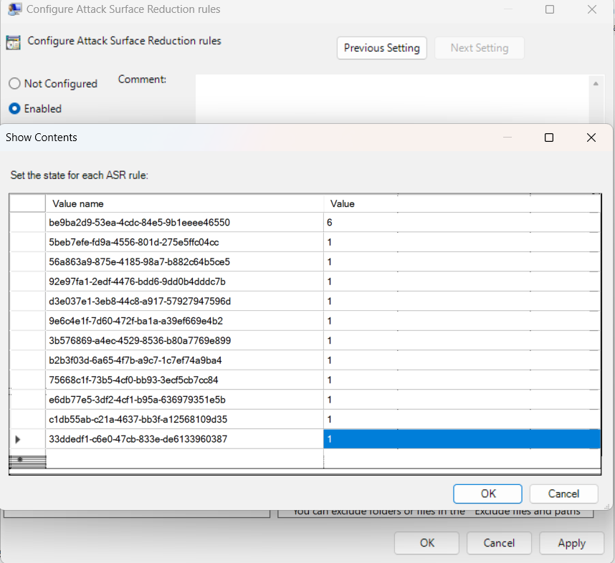
Policies then Administrative templates \Windows components\Microsoft Defender Antivirus\Microsoft Defender Exploit Guard \ Network Protection \ Microsoft Defender Exploit Guard \ Attack surface reduction \ Configure Attack Surface Reduction rules

